Here is our course notes for this week:

***This Week’s Topic(s) / Objectives***

**● Course Textbook(s) Reading Assignments**

**Review Chapters 1 and 2 in your course textbook(s)**

**● Lecture Topic: Writing HTML Code**

**● Lecture Topic: Simple JavaScript**

**• Lecture Topic: Review of Hexadecimals and Colors Tags**

**• Lecture Topic: Review of Style Sheets**

**• Deliverables: Lab 2**

**• Deliverables: Homework 2**

**• Useful Web sites**

GIF Images

[**http://www.gifanimations.com**](http://www.gifanimations.com)

Online Research Tool ( Learn HTML )

[**http://www.w3schools.com**](http://www.w3schools.com)

Online Research Tool

[**http://www.htmlgoodies.com**](http://www.htmlgoodies.com)

Online Research Tool

[**http://www.webopedia.com**](http://www.webopedia.com)

**________________________________________________________**

**Writing HTML Code**

Write the line of HTML code that will create a new paragraph that will state:

" This is my first paragraph " .

**<p>This is my first paragraph</p>**

Write the line of HTML code that will create a hyperlink to the IBM Homepage.

**<a href = "http://www.ibm.com">IBM History</a>**

Write the line of HTML code that will display this polynomial: *x* 2 + 3

**<i>x</i><sup>2</sup>&nbsp;+&nbsp;3**

Write the lines of HTML code that will display this table.

|  |  |
| --- | --- |
| row 1, cell 1 | row 1, cell 2 |
| row 2, cell 1 | row 2, cell 2 |

**<table border = "1">**

**<tr>**

**<td>row 1, cell 1</td>**

**<td>row 1, cell 2</td>**

**</tr>**

**<tr>**

**<td>row 2, cell 1</td>**

**<td>row 2, cell 2</td>**

**</tr>**

**</table>**

Write the lines of HTML code that will display this list.

An Unordered List:

Coffee

Tea

Milk

**<h4>An Unordered List:</h4>**

**<ul>**

**<li>Coffee</li>**

**<li>Tea</li>**

**<li>Milk</li>**

**</ul>**

Write the lines of HTML code that will display this list.

An Ordered List:

1. Coffee

2. Tea

3. Milk

**<h4>An Ordered List:</h4>**

**<ol>**

**<li>Coffee</li>**

**<li>Tea</li>**

**<li>Milk</li>**

**</ol>**

Write the lines of HTML code that will display this form.

|  |  |
| --- | --- |
| First name: |  |
| Last name: |  |

**<form name = "form1">**

**First name:**

**<input type = "text" name = "firstname" />**

**<br />**

**Last name:**

**<input type = "text" name = "lastname" />**

**</form>**

What do these lines of HTML code display?

**<select>**

**<option>Apples**

**<option selected>Bananas**

**<option>Bluberries**

**</select>**

**Simple JavaScript**

Using JavaScript for Form Validation.

Consider the following form.

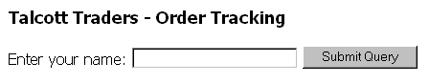

Consider this JavaScript validation function.

**<script type = "text/javascript">**

**function validate()**

**{**

**if(document.login.StudentName.value == "")**

**{**

**alert("please enter your name!");**

**return;**

**}**

**alert("Thanks for entering your name, " +**

**document.login.StudentName.value + "!");**

**document.login.submit();**

**}**

**</script>**

**Review of Hexadecimals and Colors Tags**

|  |  |  |  |  |  |  |  |  |  |  |  |  |  |  |  |  |
| --- | --- | --- | --- | --- | --- | --- | --- | --- | --- | --- | --- | --- | --- | --- | --- | --- |
| **Decimal** | 1 | 2 | 3 | 4 | 5 | 6 | 7 | 8 | 9 | 10 | 11 | 12 | 13 | 14 | 15 |  |
|  |  |  |  |  |  |  |  |  |  |  |  |  |  |  |  |  |
| **Hexadecimal** | 1 | 2 | 3 | 4 | 5 | 6 | 7 | 8 | 9 | A | B | C | D | E | F |  |

0 1 2 3 4 5 6 7 8 9 A B C D E F

Why do we use hexadecimals?

Primary Colors of Light: Red Green Blue

Primary Colors in Paint: Red Yellow Blue

For HTML color patterns.

Examples:

Using a " Named Color "

**<body bgColor = "Blue">**

Using a " Hexadecimal Color "

**<body bgColor = "#0000FF">**

Using an " RGB Triplett "

**<body bgColor = "RGB(00, 00, 255)">**

The number decimal 255 is equivalent to the hexadecimal number FF .

FF 16 = 15 × 16 1 + 15 × 16 0

FF 16 = 15 × 16 + 15 × 1

FF 16 = 240 + 15

FF 16 = 255 10

**Examples** :

Convert the hexadecimal number A5 into a decimal number.

A5 16 = 10 × 16 1 + 5 × 16 0

A5 16 = 160 + 5

A5 16 = 165 ( base ten )

Convert the decimal number 123 into a hexadecimal number.

**Quick Quiz 1**

**(1)** Any color can be thought of as a combination of which of the following three primary colors?

(a) blue, gray and yellow **(b) red, green and blue**

(c) yellow, red and blue (d) red, white and blue

**(2)** By varying the intensity of each ____ color, you can create almost any color and any shade of color that you want.

(a) hexadecimal (b) tertiary

(c) decimal **(d) primary**

**(3)** Each color on the Web is represented by a triplet of numbers, called a(n) ____ triplet.

**(a) RGB** (b) dec

(c) hex (d) primary

**(4)** In the RGB system, the absence of color is assigned the number ____ .

**(a) 0** (b) 216

(c) 16 (d) 255

**(5)** In the RGB system, the intensity of colors is assigned a number from ____ to 255 .

**(a) 0** (b) 16

(c) 1 (d) 216

**(6)** The RGB system permits ____ distinct colors.

(a) 16 (b) 255

(c) 216 **(d) 16.7 million** **( 256 3 )**

**(7)** White has an RGB triplet of ____ .

(a) ( 0 , 0 , 0 ) (b) ( 0 , 255 , 0 )

**(c) ( 255 , 255 , 255 )** (d) ( 255 , 0 , 255 )

**(8)** Yellow has the triplet ____ .

(a) ( 0 , 0 , 0 ) (b) ( 0 , 255 , 255 )

**(c) ( 255 , 255 , 0 )** (d) ( 255 , 0 , 255 )

**(9)** Originally, HTML required that color values be entered as ____ .

(a) decimals (b) WYSIWYG values

**(c) hexadecimals** (d) RBG values

**(10)** In the hexadecimal system, 16 is expressed as ____ .

(a) 1F **(b) 10**

(c) F (d) 1

**(11)** In the hexadecimal system, 21 is expressed as ____ .

(a) 1F **(b) 15**

(c) F (d) F1

**Elements of CSS ( Cascading Style Sheets )**

**Linking to a Style Sheet**

**<link type = "text/css" rel = "stylesheet" href = "basic.css">**

**Set the background color**

**<html>**

**<head>**

**<style type = "text/css">**

**body {background-color: yellow}**

**h1 {background-color: #00ff00}**

**h2 {background-color: transparent}**

**p {background-color: rgb(250,0,255)}**

**</style>**

**</head>**

**<body>**

**<h1>This is the First Header</h1>**

**<h2>This is Second Header </h2>**

**<p>This is a paragraph</p>**

**</body>**

**</html>**

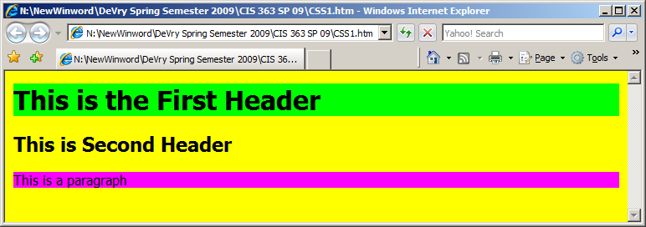

**Set the Color of the Text**

**<html>**

**<head>**

**<style type="text/css">**

**h1 {color: #00ff00}**

**h2 {color: #dda0dd}**

**p {color: rgb(0,0,255)}**

**</style>**

**</head>**

**<body>**

**<h1>This is header 1</h1>**

**<h2>This is header 2</h2>**

**<p>This is a paragraph</p>**

**</body>**

**</html>**

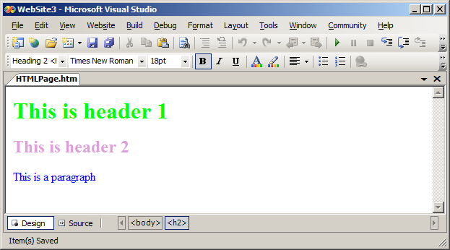

**Using CSS to Change Text Colors**

**<style type=text/css>**

**A:link { color: red /*The color of the link*/ }**

**A:visited {**

**color: #800080 /*The color of the visited link*/**

**}**

**A:hover {**

**color: green /*The color of the mouseover or 'hover'**

**link*/**

**}**

**body { color: #800080 /*The color of all the other text**

**within the body of the page*/**

**}**

**</style>**

**========**

<http://www.w3schools.com/tags/ref_colorpicker.asp>

also, some code for structure from carey text

<html>

<head><title>My WebPage</title></head>  
<body>  
  <header>  
  <h2> WEB STRUCTURE </H2>  
  </header>

 <section>  
   <article>  
   </article>

   <article>  
   </article>  
     
   <article>  
   </article>  
 </section>  
   <aside>This is fun!  
   </aside>  
</body>  
</html>

**========**

**Notepad**

**Dreamweaver**

**Visual Studio.Net**

**Adobe Coldfusion**

[**http://www.adobe.com/products/coldfusion-family.html**](http://www.adobe.com/products/coldfusion-family.html)

**Microsoft Products**

**Web Matrix**

**Expression Web**

**Google**

**Web Designer [“free”]**

**========**